**Computer Networks – LAB 3: Router Configuration (Creating Passwords, Configuring Interfaces)**

**Objective:**

* To configure a router and PCs using Cisco Packet Tracer.
* To establish network connectivity between two PCs through a router.
* To assign IP addresses and configure router interfaces for communication.
* To simulate and verify data transfer between PCs using Packet Tracer.

**Requirements:**

* Cisco Packet Tracer software.
* A GitHub account and a repository for lab assignments.
* Access to Google Classroom for submission

**Procedure:**

Step 1: Configuring Router1

1. Select the router and open CLI.

2. Press ENTER to start configuring Router1.

3. Activate privileged mode:

* Type enable

4. Access the configuration menu:

* Type config t (configure terminal)

5. Configure interfaces of Router1:

* FastEthernet0/0:
  + Type interface FastEthernet0/0
  + Configure with the IP address 192.168.10.1 and Subnet mask 255.255.255.0
* FastEthernet0/1:
  + Type interface FastEthernet0/1
* Configure with the IP address 192.168.20.1 and Subnet mask 255.255.255.0

6. Finish configuration:

* Type no shutdown to activate the interfaces

Step 2: Configuring PCs

1. Assign IP addresses to each PC:

PC0:

Go to the desktop, select IP Configuration, and assign the following:

* IP address: 192.168.10.2
* Subnet Mask: 255.255.255.0
* Default Gateway: 192.168.10.1

PC1:

Go to the desktop, select IP Configuration, and assign the following:

* IP address: 192.168.20.2
* Subnet Mask: 255.255.255.0
* Default Gateway: 192.168.20.1

Step 3: Connecting PCs with Router

1. Connect the devices using copper straight-through cables:

* Connect FastEthernet0 port of PC0 to FastEthernet0/0 port of Router1
* Connect FastEthernet0 port of PC1 to FastEthernet0/1 port of Router1

**Simulation of Designed Network Topology**

Sending a PDU from PC0 to PC1

1. Open the simulation mode in Packet Tracer.

2. Send a PDU from PC0 to PC1:

○ Observe the packet traveling from PC0 to the router and then to PC1.

**Results:** 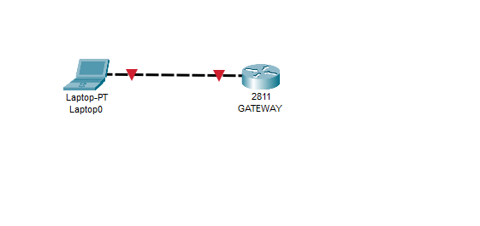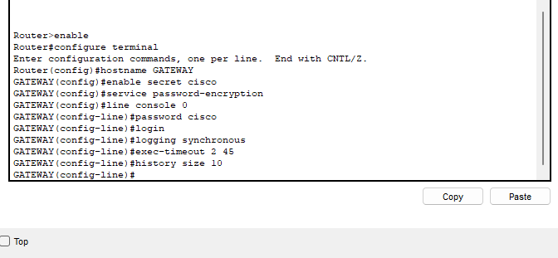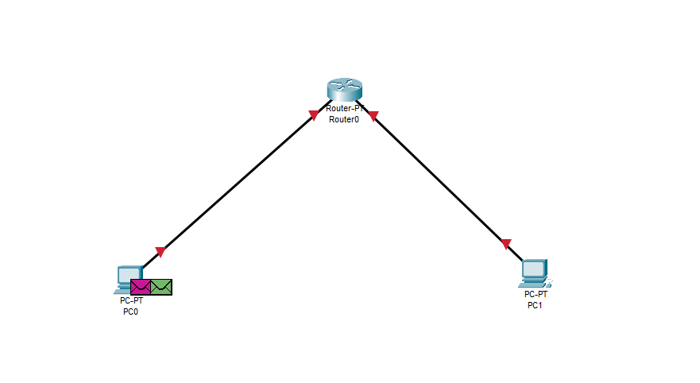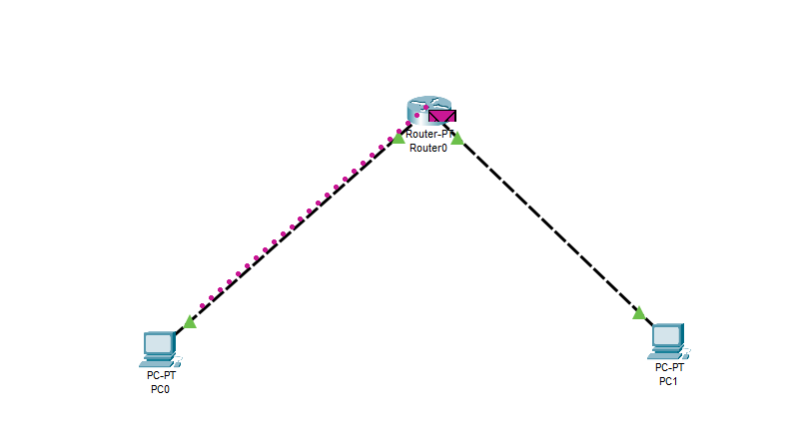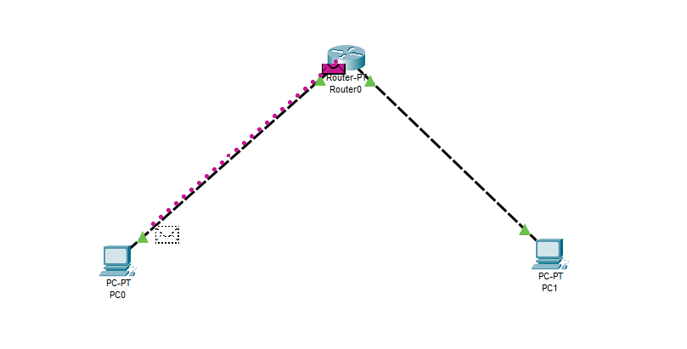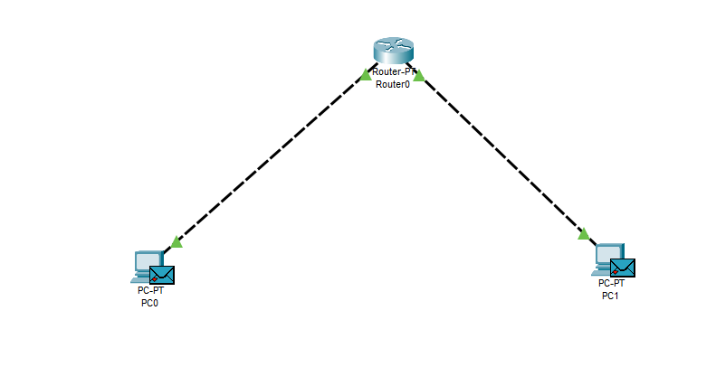

**Summary of Lab Learnings:**

In this lab, we successfully configured a basic network using Cisco Packet Tracer, involving a router and two PCs. The key learnings include:

1. **Router Configuration:** We learned how to access and configure router interfaces using the CLI, including assigning IP addresses and activating the interfaces.
2. **PC Configuration:** We practiced setting up the IP configuration on PCs, including assigning IP addresses, subnet masks, and default gateways, ensuring proper communication within the network.
3. **Cable Selection and Connectivity:** We explored the use of copper straight-through cables to connect PCs to the router, reinforcing the importance of selecting the correct cable type for different connections.
4. **Network Topology Simulation:** We tested network connectivity by sending a PDU from one PC to another, demonstrating the router's ability to route traffic between different network segments.